Unit 1: A VISIT FROM A PEN PAL
I. LISTEN: listen to the CD (Text books) and decide whether the statements are True or False. (1.0 pt)
A.1. If they go through the parking lot, they can catch a bus on Ocean Drive.
2.There are trees and flowers and a lake in the middle.
3. They want to catch the bus with the number 103.
4. Carlo loves American food.
B.1. This was the first meeting between Maryam and Lan in Malaysia.
2. Maryam was impressed because Ha Noi people were friendly.
3. They didn’t go to see a place of worship.
4. Maryam wanted to invite Lan to Kuala Lumpur.
II. MULTIPLE CHOICE: (1.5 pts)
1. Malaysia is divided ________2 regions
A. to B. on C. in D. into
2. Maryam was really ________ by the beauty of Ha Noi.
A. impressed B. impress C. impression D. impressive
3. _________Kuala Lumpur, Ha Noi is a busy modern city
A. As B. Such as C. Like D. Similar
4. Long ago people used to ________the sun, the stars and the moon.
A. hate B. worship C. love D. dislike
5. I wish I ___________his name.
A. knew B. know C. will know D. would know
6. Minh’s father often takes him ______ the park every summer.
A. on B. to C. in D. after
7. Lan ________the peaceful atmosphere while Maryam was praying.
A. enjoying B. has enjoyed C. enjoyed D. enjoy
9. The United States has a ________ of around 250 million.
A. population B. separation C. addition D. introduction
10. Vietnamese people are very ________ .
A. friend B. friendless C. friendly D. friendship
11. We were having dinner ________ the telephone rang.
A. when B. while C. until D. since
12. I ________call you as soon as I come back home.
A. have B. will C. am D. is going
13. Would you mind ________the door?
A. open B. opened C. opening D. to open
14. That teacher is a (n) __________ one. His pupils like his sense of humor.
A. amusing B. amused C. amusement D. self- amused
15. The children are playing ________in the schoolyard.
A. happy B. happiness C. happier D. happily
16. Mrs. White is very________. She goes to church everyday.
A. religion B. regional C. religious D. region
17. What’s the ________of Malaysia? Is it the ringgit?
A. currency B. money C. unit D. money symbol
18. The living room and the dining room are________by a short wall where there are many decorative plants.
A. broken B. divide C. parted D. separated
19. “Excuse me; can I book a ticket for Paris?” “__________________”
A. Hurry up B. Thank you C. Never mind D. Certainly
20. “So how are things at school, Tim?” “________________”
A. Oh, pretty good, actually. B. Well, I can’t agree with you.
C. It’s my pleasure. D. I was not very good at it
III. CAUTION SIGNS – WARNINGS (0.5 pt)
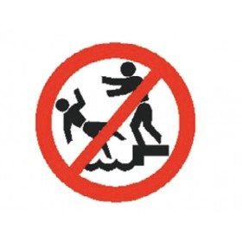  1) What does the sign say? | - No jumping  - No chasing  - No pushing  - No running
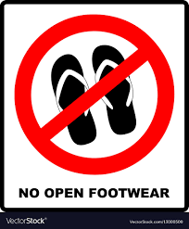  2) What does the sign say? | A. No high heels  B. No expensive shoes  C. No worn-out shoes  D. No open footwear
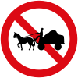  3) What does the sign say? | - People are working here  - Safe road  C. No animal-drawn vehicles  D. No humans or animals
  4) What does the sign say? | - No goods vehicles  - No motorcycles  C. No agricultural vehicles  D. No motor vehicles
  5) What does the sign say? | - No goods vehicles  - No cyclists  - No trains  - No agricultural vehicles
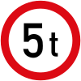  6) What does the sign say? | - Maximum length limit  - Maximum width limit  - Maximum weight limit  - Maximum height limit
  7) What does the sign say? | - Roadworks  - Traffic signals ahead  - Swing bridge ahead  - Slippery road
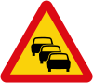  8) What does the sign say? | - Other danger  - Traffic queues  - Human queues  - Stop ahead
9) What does the sign say?  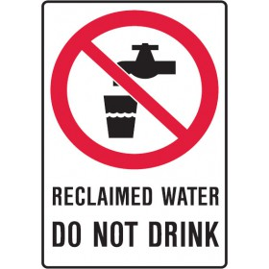 | - Other danger  - Free water  - Don’t touch the glass  - Don’t drink water
9) What does the sign say?   | A. No smartphone use  B. No texting  C. No talking  D. No dialing
10) What does the sign say?  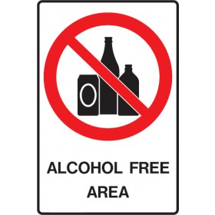 | A. Alcohol is allowed in this area  B. Get free alcohol in this area  C. Alcohol is disallowed in this area  D. Buy recyclable bottles in this area
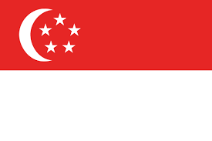  11) Which country is this? | - Malaysia  - Indonesia  - The Philippines  - Singapore
12) Which country is this?  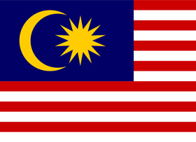 | A. Malaysia  B. Indonesia  C. The Philippines  D. Singapore
13) What does the sign say?  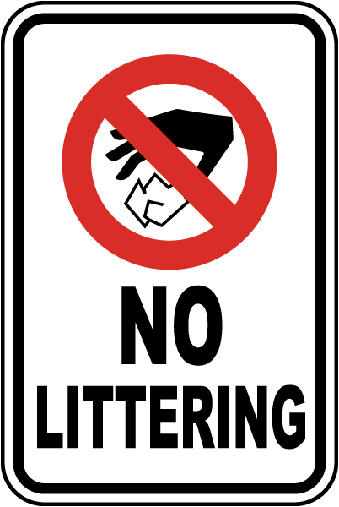 | A. No touching  B. No paper  C. No littering  D. No picking
14) What does the sign say?  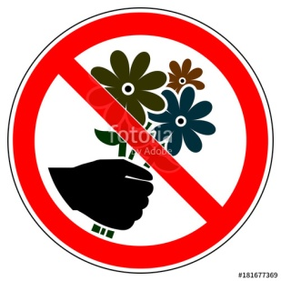 | A. No giving flowers  B. No cutting grass  C. No littering  D. No picking flowers
15) What does the sign say?   | A. No shoes  B. No barefoot  C. Don’t touch the flowers  D. Keep off the grass

IV. CLOZE TEXT. (1.5pts)
Malaysia is a country in Southeast Asia. It borders Thailand and is surrounded by the sea. Malaysia became an independent nation in 1963 after (1)_____________ by Great Britain for many years. It has a very strong economy that (2)__________ tourism and trade.
(3)_________________ its location in the South Pacific ocean, the (4)____________ of Malaysia is tropical. This means that is very hot and humid. Also, the temperature does not change much throughout the year. Malaysia’s general weather conditions make (5)___________ a wonderful place for many plants and animals to live. In fact, Malaysia is one of the world's most diverse ecosystems.
In 2001, Malaysia was ranked as one of the top 12 diverse countries in the world in terms of biology (plants and animals). It is believed that over 170,000 different kinds of plants and animals live in Malaysia. In fact, scientists think that nearly 20% of the world's animals (6)____________ in Malaysia now. Malaysia is home to tigers, elephants, rhinos, turtles, and many different kinds of monkeys including Orangutans.
1. A. having ruled B. ruled C. being ruled D. ruling
2. A. composes of B. comprise C. consists D. includes
3. A. As B. In spite of C. Therefore D. Because of
4. A. weather B. climate C. temperature D. condition
5. A. it B. they C. that D. them
6. A. lives B. live C. lived D. living

Singapore is a country in Southeast Asia. Until 1965, Singapore was ruled by the United Kingdom. In 1965, they gained their (1)_____________ and established their own government.
Singapore's economy is very strong in a number of different areas. (2)________________ its large and centrally located port, import and export is an important part of Singapore's economy. "Import" means bringing items into the country and "export" means sending items out of the country. Many of the goods imported and exported are electronics and technology or are related to chemical, oil, or medical supplies.
Another area that is important to Singapore's economy is finance. Singapore is the world's (3)______________ financial center after New York, London, and Tokyo.
Over 10,000 companies from around the world have offices in Singapore. As a result of having so many multi-national companies, nearly half of the people who work in Singapore are from other countries.
Singapore is (4)_____________ for being a clean and safe country that has many interesting sites to see.
Thanks to its diverse economy, Singapore is a very wealthy nation. In fact, it is one of the top ten richest (5)_______________ in the world. Many people in Singapore are millionaires (6)__________ some are very poor. It is a small country, but serves as a model for other nations when looking at their own economics.
1. A. dependence B. correspondence C. free D. independence
2. A. Despite B. Due to C. Because D. In spite of
3. A. four-largest B. largest-fourth C. fourth-largest D. forth-largest
4. A. well-known B. considered C. impressed D. dangerous
5. A. nation B. continents C. countries D. provinces
6. A. so B. because C. however D. but

V. READING COMPREHENSION (1.5 pts)
A. Reading plays an important role in our lives. Not only is it the fastest way to reach for new information and new knowledge, but it is also useful in building maturity and widening awareness of contemporary issues. Besides, reading gave human the ability to think deeply and seek for changes, which is especially important for people in Malaysia which has the vision of becoming an advanced country in 2020. However, despite being one of the countries in South-East Asia with the highest literacy rate (93.2%), Malaysia is still far behind developed countries like Japan, United States and Britain, which have a literacy rate of 99%.
Malaysia is suffering a poor reading culture among the citizens. It was found that Malaysians are only keen on reading books that are related to their work field or of light genre. They opined that reading things that are not to their interest is a waste of time and will not contribute to self-development, in which such mindset had prevented them from reading to expand knowledge. Also, most Malaysians were not inculcated to read since they were young, and they are less willing to spend money to buy quality books.
1. Reaching for new information and knowledge is the only benefit we gain from reading.
2. Malaysia is the country with the highest literacy rate in the world.
3. Citizens in Malaysia love reading books which are related to their work field or of light genre.
4. Most Malaysians were taught to read since they were young.
Read the text again and choose the best answer for these questions
5. What is the passage mainly about?
    - The reasons why Malaysia has the highest literacy rate in South-East Asia.
    - The benefits of reading and ways to encourage reading in Malaysia.
    - The importance of reading to Malaysians and their reading culture.
    - The difference in reading culture between Malaysia and other countries.
6. The word ‘inculcated’ in the paragraph means:
- ordered
- learned
- taught
- told

B. The historic summit between the United States and North Korea will take place next month in Singapore, about 5,000 kilometers south of the North Korean capital, Pyongyang. Some reasons the tiny city-state was chosen as the site.
Security:
Singapore is well-known for putting together top-level international gatherings at short notice. Since Singapore gained independence in 1965, it has become one of the safest countries in the world.
Past experience:
Singapore also hosted a historic meeting between Chinese President Xi Jinping and then-Taiwan President Ma Ying-jeou in November 2015. That meeting — the first between the leaders of the governments in Beijing and Taipei since the civil war ended seven decades earlier — was arranged secretly.
Diplomatic ties:
Singapore is a large trading partner with the U.S., the second-largest Asian investor, and a longtime supporter of its military presence in the Asia-Pacific region. It is also the regional headquarters of large U.S. companies including Google, Facebook and Airbnb.
Singapore is one of about four dozen countries in the world where North Korea has an embassy. North Korea's state-owned companies have, in the past, conducted legal and illegal business dealings with Singapore businesses. The city-state officially cut off trade relations with North Korea in 2017 to obey international sanctions.
1. Singapore has never held any top-level international gatherings at short notice before.
2. Since gaining independence, Singapore has become a dangerous place.
3. The United States is no longer the second-largest Asian investor.
4. North Korea only opens embassies in about 48 countries across the world.
Read the text again and choose the best answer for these questions
5. Topic of the text may be:
- The historic meeting between the United States and North Korea.
- The successful meetings Singapore has held so far.
- The diplomatic ties between Singapore and the U.S..
- The reasons why Singapore is a perfect place for US-North Korea meeting.
6. The word ‘sanction’ in the paragraph means:
A. disagreement
B. prevention
C. law
D. approval
VI. WORD FORMS (1.5 pts)
- Numerous items of ______________________ have been received on this subject. (CORRESPONDENT)
- Her sudden ________________ towards him was suspicious. (FRIEND)
- Their _____________were answered and the child was found safe and well. (PRAY)
- ________________ between the rich and the poor seem to grow ever wider. (DIVIDE)
- There are no _______________ on students to attend classes. (COMPEL)
- Space travel is one of the wonders of _______________ science.(MODERNIZE)
- That was an ________________ performance from such a young tennis player. (IMPRESSION)
- The teams are playing a __________________ match on Sunday. (FRIEND)
- I need a _____________ baby-sitter. (DEPEND)
- They proposed making secondary education ______________ up to the age of 18. (COMPEL)
- Much of the house has been __________________________. (MODERN)
- She likes to spend time ___________________ her home. (BEAUTY)
- He tried to _________ me with his extensive knowledge of wine. (IMPRESSION)
- Let us _______________ for the victims of this terrible disaster. (PRAYER)
- The law can ____________ fathers to make regular payments for their children. (COMPULSORY)
- The scores of those students are always __________________ high. (IMPRESS)
- He was back in her arms and she could once again sleep ____________. (PEACE)
- The two departments work ________________ of each other. (DEPEND)
- The evening passed ______________. (ENJOY)
- Their house is _________________ decorated. (BEAUTY)

VII. WRITE (2.5 pts)
TRANSFORMATION
1. Thousands of people have to build that castle for him for years.
That castle .......................................................................................................................
2. She doesn’t send me her recent photos.
I wish .................................................................................................................................
3. He failed in the examination last year.
He did not ........................................................................................................................
4. I haven’t eaten this kind of food before.
This is the first ................................................................................................................
5. His parents made him study for his exam.
He was made ..................................................................................................................
6. I don’t really want to go to the museum.
I’d rather...........................................................................................................................
7. The fire has destroyed many houses.
Many houses ...................................................................................................................
8. May I borrow your pen?
Would you mind ...........................................................................................................?
9. I started to work for the company a year ago.
I’ve .................................................................................................................................
10. She didn’t say a word as she left the room.
She left .........................................................................................................................
11. I don’t find it difficult to get up early in the morning.
I am used to ………………………………………………….........................................
12. Robinson doesn’t find it easy to live alone on this island.
Robinson doesn’t …………………………..…………………………………………...
13. He always goes swimming after finishing his work.
- He is used to…………………………..…………………………………………………
14. My father used to play football when he was young.
My father doesn’t ……………………………………………….............…...…………..
15. They used to make these vases by hand
These vases……………………………………………………………………………..
16. His father no longer goes fishing with him.
His father used to ………………………………………………………………………
17. Please keep quiet in the classroom
I’d rather you……................…………............................................................................
18. “Would you mind not smoking in here?”
I’d rather ……................………….............................................…...............................
19. Don’t tell anyone what I said.
I’d rather you ……................………….........................................…............................
20. It is high time we went home.
It is high time ………………………………………………………………………….
21. You really should be able to dress yourself by now
It’s high time …………………………………………………………………………..
22. It is high time for you to go to school.
It’s about ……………………………………………………………………………….
REARRANGE:
1. give robots/ themselves/ the job they can’t / Americans / want to do/ do or don’t
- Americans_______________________________________________________
2. robot-loving people/ The Japanese/ the most /in the world/ are probably
- The Japanese _____________________________________________________
3. very eager/ with robots/ In the USA, / are not/ to interact/ people
- In the USA, ____________________________________
4. see their robots/ get emotional/ Japanese people/ as companions / that they can/ support from
- Japanese people _________________________________________
5. at home when/ leave their phones/ that students should /Many people believe/ they go to school
- Many people believe ______________________________________
6. walking to or/ feels threatened, / call for help/ If a student is / from school and/ he or she can
- If a student is ________________________________________
7. spend their time/that some students/ listening in class/ Teachers say/ texting instead of
- Teachers say _____________________________________________
8. make rules for/ to use their phones/ students are allowed / Schools should/ when and where/
- Schools should __________________________________________________
9. advanced robot / is the/ in the world/ Asimo/ most technologically/
- Asimo ______________________________________________________
10. get them/ their mobile phones/ to come and / Students use/ to call their parents
- Students ___________________________________________________________

